Aggregate functions

Count: The no of products whose quantity is greater than 1

Query:

SELECT COUNT(*) FROM product WHERE qty=1;

Frontend:



Backend:

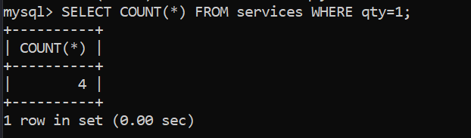

SUM: Total Amount of Estimated price whose quantity is greater than 1.

Query:

SELECT SUM(estimated_price) FROM services WHERE qty>1;

Frontend:



Backend:

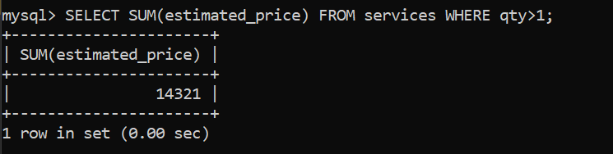

AVERAGE: The Average of the Total Cost

Query:

SELECT AVG(total_price) FROM payment;

Frontend:



Backend:

